**NDATE v5.2.0 User Guide**

**Date: July 29th, 2020**

**Revision: A1**

Contents

1.0 NDATE REQUIREMENTS 3

1.1 5.2.0 – Requirements 3

1.2 Drive Test Configuration 3

1.3 Client Host Configuration 3

1.4 Web Server ONTAP Kernel Installation 3

1.5 Terminal Server 4

1.6 User Access Levels 4

1.7 Test Fabric Knowledge 4

2.0 Using NDATE 5

2.1 Wrapper 5

2.1.1 Option 1 – Execute Test Suite 6

2.1.2 Option 2 – Create/Update/DeleteTest Suite 7

2.1.2.1 Test Suite Name 8

2.1.2.2 Selecting Test Type/Config Type 9

2.1.2.3 Group Listing 9

2.1.2.4 Filer Selection 10

2.1.2.5 Test Execution 11

2.1.3 Option 3 – Create/Update/Delete Filer Configuration Files 12

2.1.4 Option 4 – Update NDATE Package 16

2.1.5 Option 5 – Execute the Last Test Suite 16

3.0 Test Report Analysis Test 17

**Error! Hyperlink reference not valid.Error! Hyperlink reference not valid.Error! Hyperlink reference not valid.Error! Hyperlink reference not valid.Error! Hyperlink reference not valid.Error! Hyperlink reference not valid.Error! Hyperlink reference not valid.Error! Hyperlink reference not valid.Error! Hyperlink reference not valid.Error! Hyperlink reference not valid.Error! Hyperlink reference not valid.Error! Hyperlink reference not valid.Error! Hyperlink reference not valid.Error! Hyperlink reference not valid.Error! Hyperlink reference not valid.Error! Hyperlink reference not valid.Error! Hyperlink reference not valid.Error! Hyperlink reference not valid.Error! Hyperlink reference not valid.Error! Hyperlink reference not valid.Error! Hyperlink reference not valid.Error! Hyperlink reference not valid.Error! Hyperlink reference not valid.Error! Hyperlink reference not valid.Error! Hyperlink reference not valid.**

# ****NDATE REQUIREMENTS****

**There are several requirements that need to be met in order to successfully run NDATE. These requirements are discussed here.**

# ****5.2.0 – Requirements****

**NDATE v5.2.0 is first version of tool to support SDF drives, as ONTAP support is very minimal and ONTAP SDF support is under development phase, this version requires system / filers to be configured and bought up in File system mode.**

**Make sure Filer is in**

* **File System – CLI**
* **Configured as Cluster, Disable Failover and Ha.**

**Check_filer_setup will set required boot args and assigns SDF drive.**

**Note: Future release of NDATE will support booting in required mode and setting up cluster.**

# ****Drive Test Configuration****

NDATE is a tool that is primarily used to execute automated NVMe drive tests during the pre-qualification phase at various drive vendor sites as well as during the qualification phase at NetApp. NDATE has been tested with the AFF series of filers. These filers should be loaded with the respective kernel version to be used for product qualification.

# ****Client Host Configuration****

NDATE is installed on the Client Host for executing the automated tests on the specified filer(s). Currently, NDATE tool must be installed and executed from Client Host running Linux OS. NDATE tool has been tested on Client Host(s) running Red Hat Linux OS - Enterprise Server 5 (64-bit).

# ****Web Server ONTAP Kernel Installation****

NDATE 5.2.0 supports kernel version 9.5 onwards. The kernel image should be located on a functioning web server and the complete path of the kernel location should be added within NDATE when it prompts for the image location. Refer to the below example:

**Example**: [https://172.23.8.10/<image_location>](https://172.23.8.10/%3cimage_location%3e)

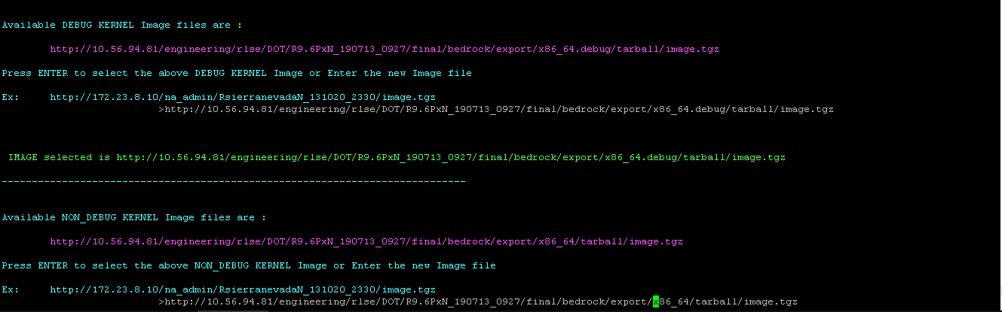

Figure 1

# ****Terminal Server****

A configured terminal server is required for NDATE to execute automated drive qualification tests as NDATE will connect to the specified filers using the terminal server IP Address as well as the serial port (#) at which the filer is connected to this terminal server.

# ****User Access Levels****

NDATE is available for use by NetApp Storage Media Engineering Team as well as by various Drive Vendors for prequalification testing of drives.

The installation of NDATE is done on a Client Host. The execution of automated drive tests on a given Filer setup can be done by any non-privileged user, However the user should have sudo privileges for executing the tests.

# ****Test Fabric Knowledge****

A test user should have a basic understanding of the following:

* Filer Network Configuration Terminologies (e.g. IP Address, Gateway, Netmask)
* Filer Configuration setup (Terminal server, Port #)
* TFTP, Unix, and Web Server setup for ONTAP kernel file reference (netboot)
* Basic Linux/Unix commands



































# ****Using NDATE****

Once the installation is complete without any errors, the user can invoke NDATE by executing it via the following command:

#./ndate

Invoking the help option when invoking NDATE will display options that may be used when running NDATE:

# ./ndate -h

# ****Wrapper****

After installing the package successfully, the main script wrapper (**ndate**) is running and the options are listed below:

**NOTE:**

**Options marked ** is for internal NetApp use only. External users should not use these options. Using these internal options might lead to change in configurations which may lead to issue.**

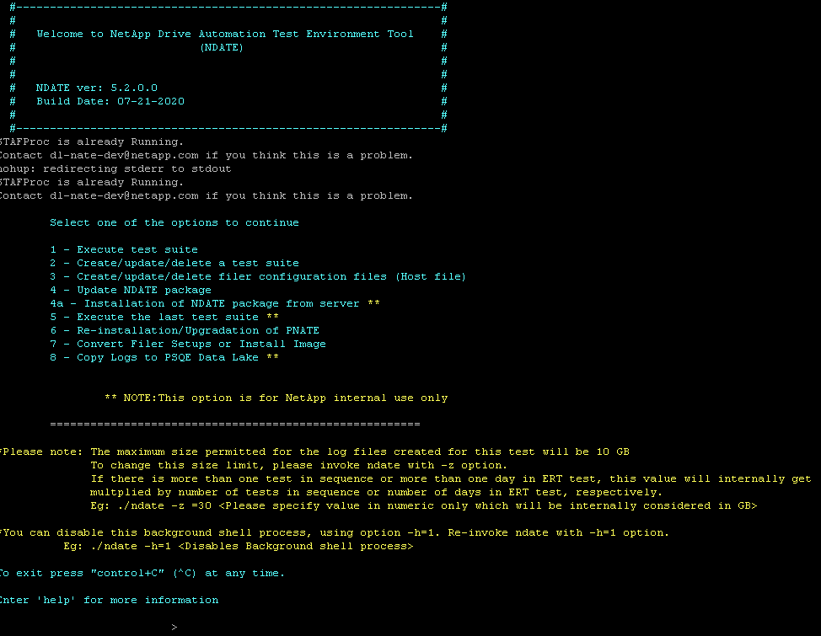

Along with the menu of options, there is a note to change the log size. Follow the instructions given there if the log size needs to be changed.

**NOTE**

**Execution of SAS is not supported on NDATE 5.1.x, though it has SAS menus.**

# ****Option 1 – Execute Test Suite****

Option 1 from the NDATE menu is used to execute test suite that has previously been created. A list of available test suites will be displayed. Enter the name of the desired test suite and press Enter. If there are no previously created test suites, NDATE will force the user to create a new test suite.

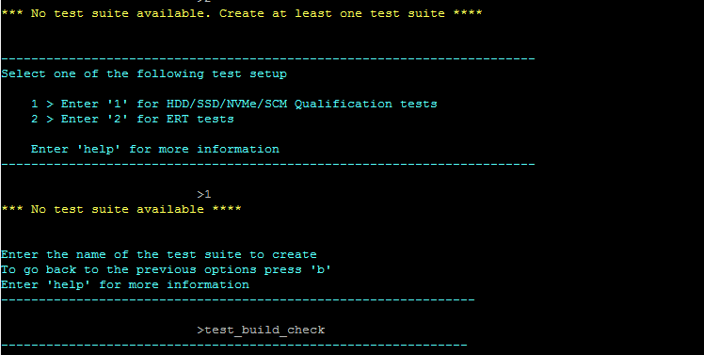

Figure 3

# ****Option 2 – Create/Update/DeleteTest Suite****

OPTION 2 in NDATE is used to create, update and delete test suites. Selecting this option, NDATE prompts the user to create/update/delete test suite.

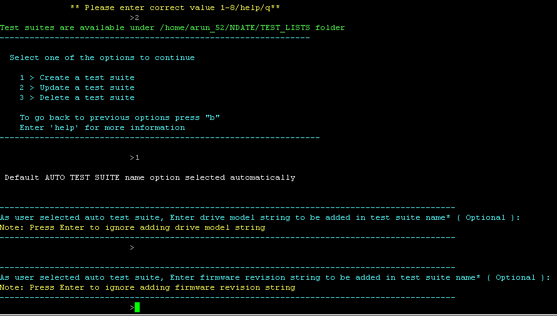

User can enter drive model or firmware to create unique test suite. These are optional field; Press enter to proceed.

# ****Test Suite Name****

A test suite is a combination of test cases and filers on which test cases will be executed on or against. NDATE allows the user to execute the same or multiple test or tests on filers. Once selected option 1(Create a test suite), the user needs to enter a test suite name. Once a test suite name is entered.

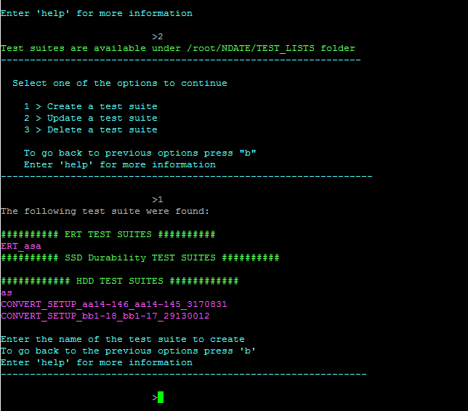**Selecting Kernel Image**

Figure 6

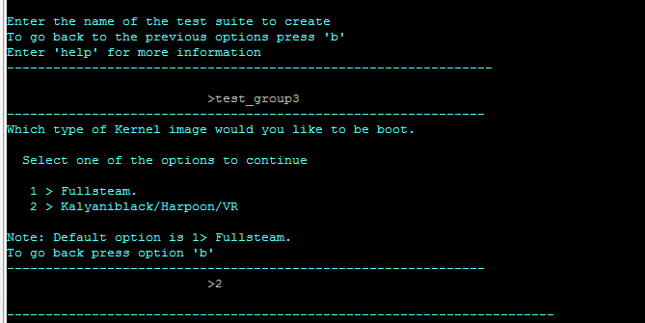After creating test suite name, NDATE will prompt for kernel selection.

Figure 7

# ****Selecting Test Type/Config Type****

**NDATE v5.2.x** supports ZNS/SDF drives. Available groups and tests will be displayed based upon user selected configuration types.

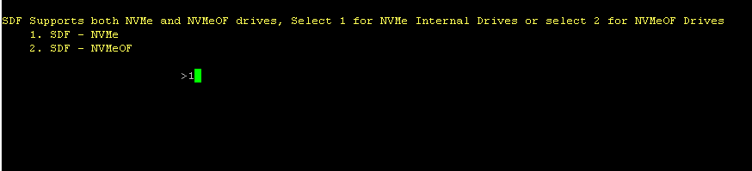

Based on user selected config options, test scripts will be displayed.

For Apollo-Tahiti - Refer to the connection diagram, use option 9 to select Tahiti supporting scripts

For Apollo - Supports only internal drives. Use option 8 for Internal NVMe drives

For SCM - Requires Flash Cache drive. Use option 4 to select SCM supported tests

# ****Group Listing****

Available groups are displayed, and the user should then select required groups in order to select a test and execute. Once the user selects a group, a list of tests available will be displayed.

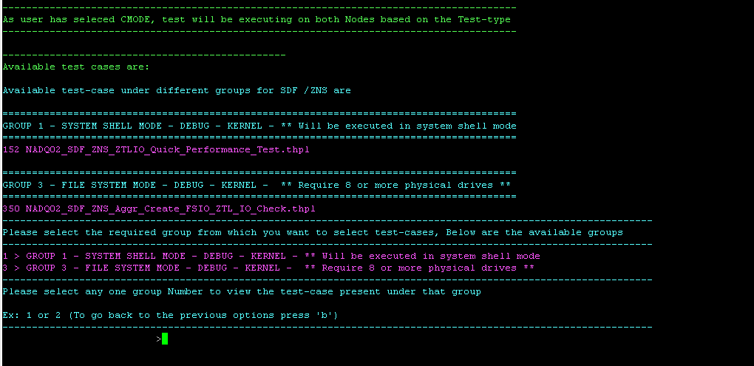

List of tests under selected group.

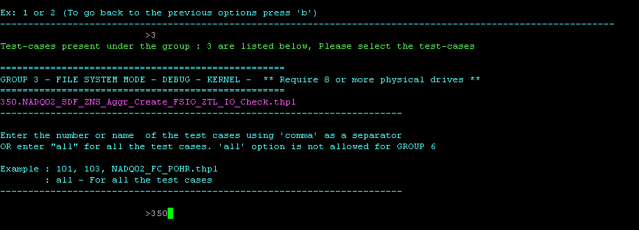

# ****Filer Selection****

A user will have filer configs under “NDATE/FILER_INFO”. NDATE will display available filers for test execution. If no filer config file is present, use option 3 from the main menu and create the new filer config with all relevant details, then select two (2) filers for execution of the prior selected test.

Figure 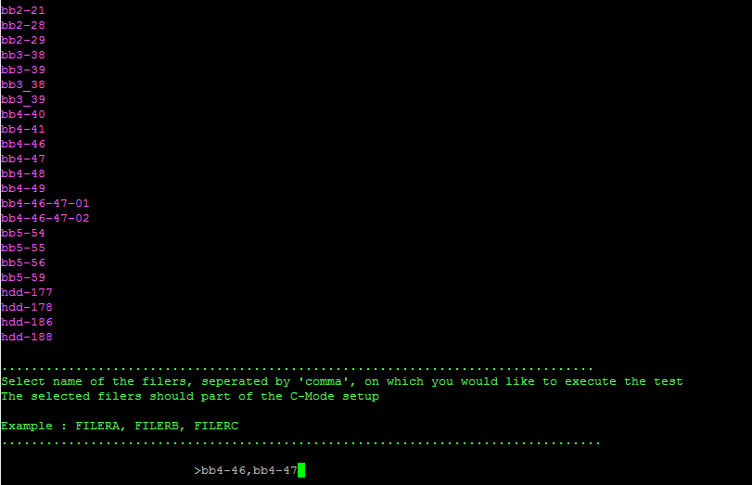11

# ****Test Execution****

After selecting the required filers, NDATE will prompt for execution of test suite. Press "y" and the test suite will begin. The location and relevant details concerning the log directory will be printed on the console.

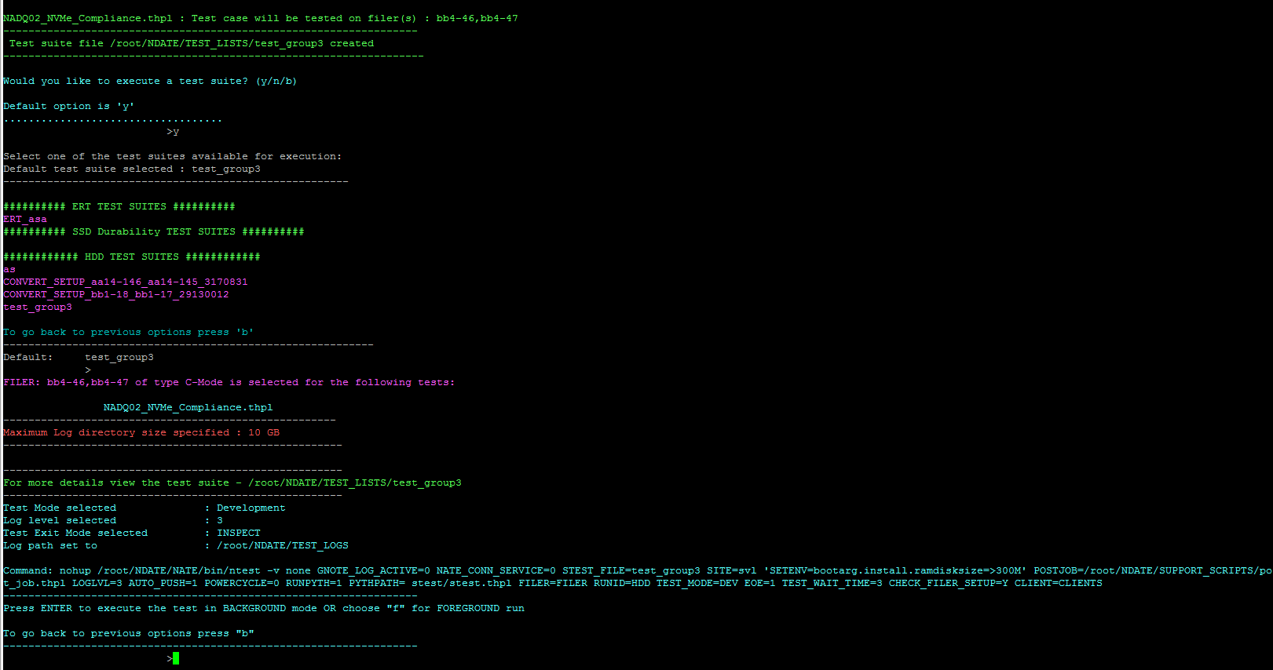

Once the test suite is complete, the user will receive an email with a status update including results/logs which are available under the prior specified log directory.

# ****Option 3 – Create/Update/Delete Filer Configuration Files****

Filer configuration files are used to store relevant characteristics of each filer used for configuration reference by NDATE. Each filer **must** have a filer configuration for NDATE to execute on that setup.  All required details of each filer must be provided in the filer configuration files. Filer configuration file(s) must be created before using that filer in a NDATE environment, Filer creation/updating configuration file can be done using VI editor or using CLI. It performs basic parameter validation. The user should select option 3 from the menu.

NDATE will prompt filer configuration menu.

Figure 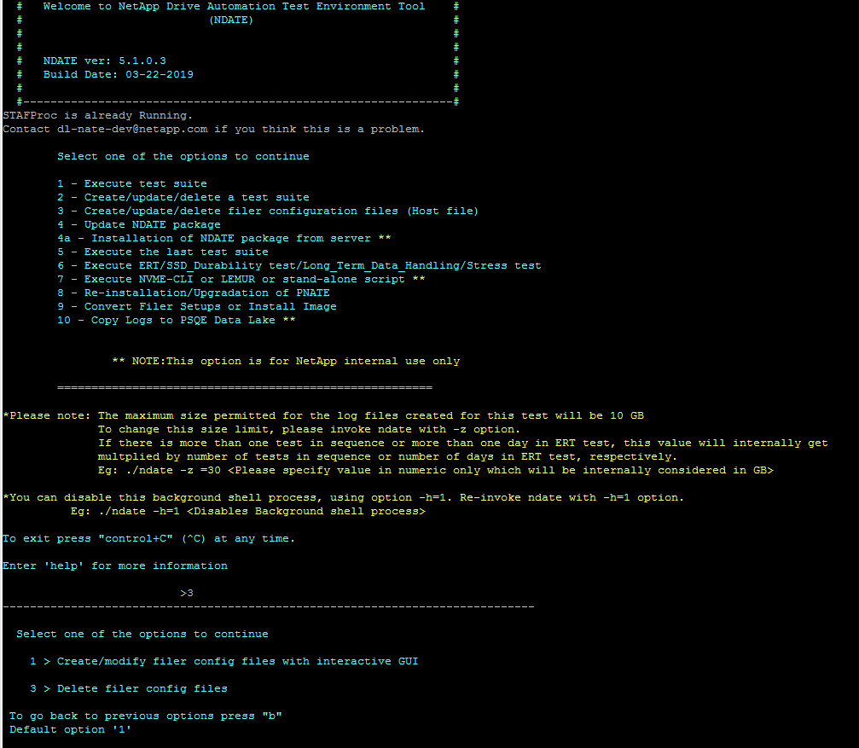13

User can create and delete filer configs using above options.

Enter the filer name you wish to create or modify if a filer config is available, NDATE will open the filer config for editing. If the filer config is not available, NDATE will create one and the relevant filer details need to be given or modified.

Figure 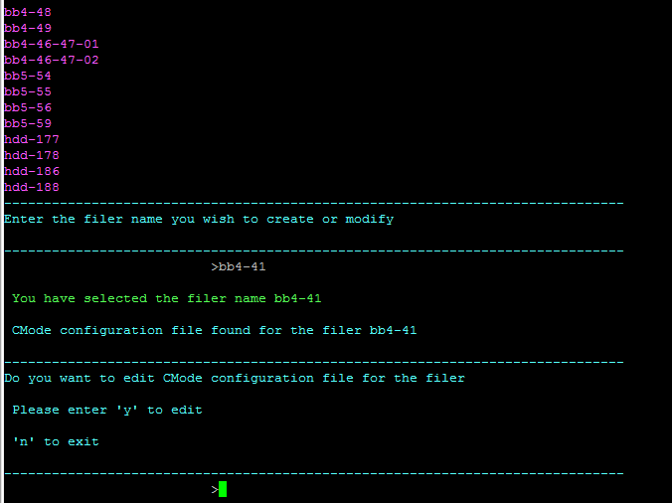14

Once a user has selected required option, filer details will be displayed for editing and the user will then edit/update/add filer details and save using **:wq!** . This will save the filer config and then prompt for confirmation.

All required parameters are necessary to proceed, (CTRL + C) if you want to exit or if you don’t have all the details of filer.

Enter "**f**" to finish editing.

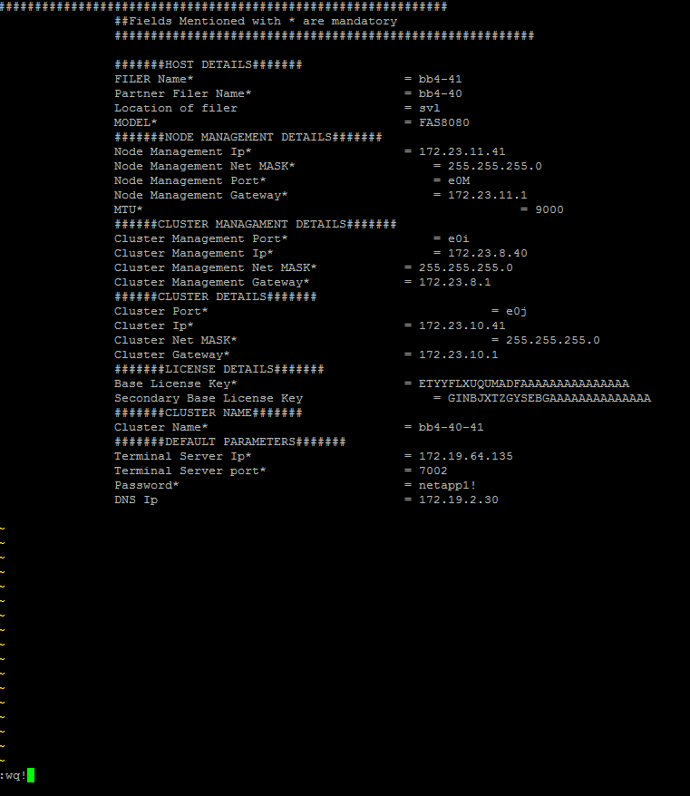Follow same steps for partner node/filer.

Figure 5

Figure 6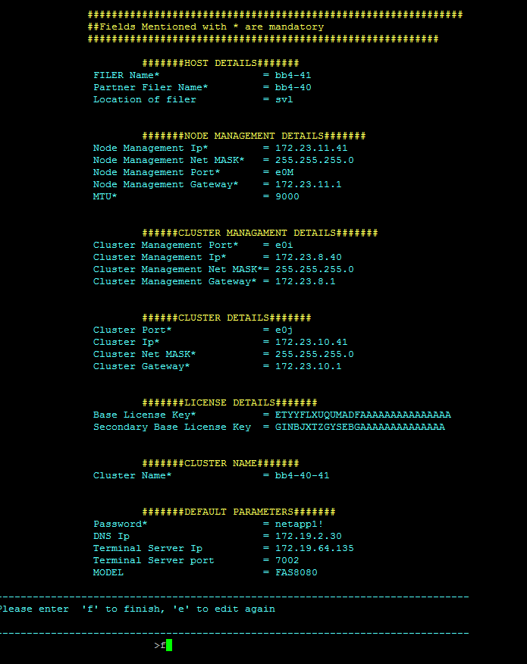

# ****Option 4 – Update NDATE Package****

NDATE has to be correctly installed before updating. Delete any previous tar.gz files.

rm -rf *.tar.gz

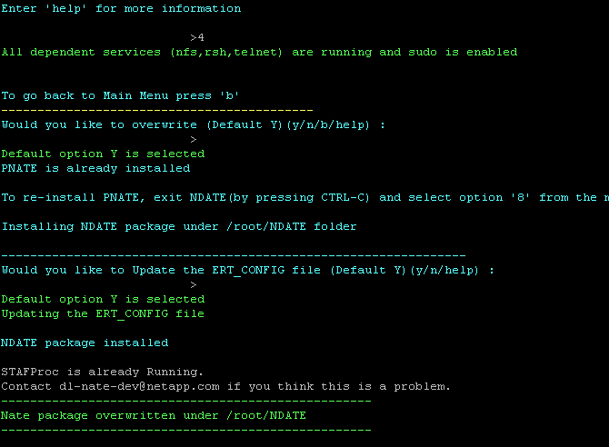and copy v5.1.1 **NDATE package files - ndate, NDATE.tar.gz, PNATE.tar.gz** to home directory before using this option.

Figure 7

# ****Option 5 – Execute the Last Test Suite****

Running this option will run the last test suite that was run.

about PNATE refer NDATE installation guide.

**IMPORTANT**

For Apollo, Apollo-Tahiti - Auto switching of a kernel is **NOT** supported, The same kernel (debug or non-debug) **MUST** be loaded in both image locations.

# Test Report Analysis ****Test****

NDATE generates a Test Specific NDATE log, a Console log, an END log, a result log, and also a summary log for user analysis. For cluster setup, it generates separate logs for the two filers (two NDATE logs, two Console logs, two END logs and two result logs). While using cluster setup, some commands need to be executed in parallel on both the filers. This is accomplished by using a subtest. When these parallel processes execute, two separate log files are created, one for each filer. The name of these log files is similar to the *runid* associated with the subtest. These log files will contain the output of the command executed through the subtest. The main logs indicate the start and end of the subtest on both of the filers. After the test, user should check the test status from the ‘Summary result log’ and look for minimum log details from ‘Test result log’. User should check the ‘nate log file’ or console log if more information is required. The parser will parse .log file and generate a readable text file.

The SYSTEM LOGS folder under main log directory will contain both ems logs and sktrace logs. sktrace logs will contain the NVMe commands send to the drives and the completion status. For NVMe testing, sktrace logs provides more drive specific details than ems logs for failure analysis. sktrace logs collected for all tests other than performance will not record any IO commands send to the drives. For performance tests, NDATE will generate sktrace logs that records all IOs send to the drive during the entire test duration. A separate parser is available to parse this sktrace log to identify the traffic pattern coming to the drive.

The location of the log and result files generated are mentioned by the wrapper on the Client Host console. The parser will determine the overall pass/fail state of a test case. The parser executes after each test case execution and decides the pass/fail based on the rules defined for the test case. The parser takes the log data and compares with the rule files (common rules and test case specific rules). Common rules are based on EMS errors. The parser generates one consolidated results file for all the test cases running on the different filers and also generates a readable result file for each log.