NDATE v5.2.0 User Guide

Date: December 2020

Revision: A1

Contents
1.0 NDATE Requirements 3
1.1 5.2.0 – Requirements 3
1.2 Drive Test Configuration 3
1.3 Client Host Configuration 3
1.4 Web Server ONTAP Kernel Installation 3
1.5 Terminal Server 4
1.6 User Access Levels 4
1.7 Test Fabric Knowledge 5
2.0 Using NDATE 5
2.1 Wrapper 5
2.1.1 Option 1 – Execute Test Suite 7
2.1.2 Option 2 – Create/Update/Delete Test Suite 8
2.1.2.1 Test Suite Name 9
2.1.2.2 Selecting Test Type/Config Type 9
2.1.2.3 Group Listing 10
2.1.2.4 Filer Selection 11
2.1.2.5 Test Execution 12
2.1.3 Option 3 – Create/Update/Delete Filer Configuration Files 13
2.1.4 Option 4 – Update NDATE Package 18
2.1.5 Option 5 – Execute the Last Test Suite 18
3.0 Test Report Analysis 19

NDATE Requirements
To successfully run NDATE, it is important to ensure that all requirements are met. This document explains about those requirements.

5.2.0 – Requirements
NDATE v5.2.0 is the first version of the tool. It supports SDF drives because ONTAP support is very minimal and ONTAP SDF support is under development phase. This version requires system/ filers to be configured and brought up manually into File system mode.
Ensure that the filer is in
- File System – CLI
- Configured as Cluster, Disable Failover, and Ha.
Check_filer_setup will set up the required boot args.

Note: Future release of NDATE will support booting into required mode and setting up of cluster.

Drive Test Configuration
NDATE is primarily used to execute the automated SDF/ZNS Drive tests during the pre-qualification at Drive vendor sites and qualification phase at NetApp site. NDATE has been tested with the AFF series of filers. These filers should be loaded with the respective kernel version required for product qualification.

Client Host Configuration
NDATE is installed on the Client Host for executing the automated tests on the specified filer(s). Currently, NDATE tool must be installed and executed from Client Host running Linux OS. NDATE tool has been tested on Client Host(s) running Red Hat Linux OS - Enterprise Server 6.9 (64-bit).

Web Server ONTAP Kernel Installation
NDATE 5.2.0 supports kernel version SDF-v1 onwards. The kernel image should be located on a functioning web server and the complete path of the kernel location should be added within NDATE when it prompts for the image location.
For example: https://172.23.8.10/<image_location>
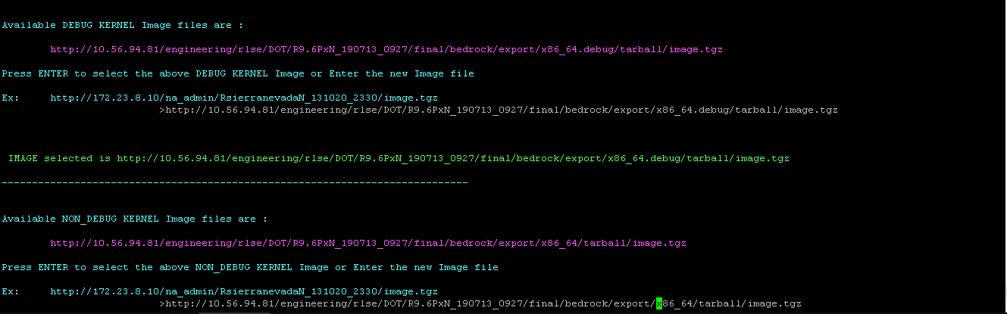
Figure 1

Terminal Server
A terminal server configured with NDATE is required to execute automated drive qualification tests. NDATE will connect to the specified filers using the terminal server IP Address and the serial port (#) at which the filer is connected to this terminal server.

User Access Levels
NetApp Storage Media Engineering Team and various Drive Vendors can use NDATE for prequalification drive tests. NDATE is installed on a Client Host. Any non-privileged user can execute automated drive tests on a given filer setup. However, the user must have sudo privileges for executing the tests.

Test Fabric Knowledge
As a test user, you should have a basic understanding of the following:
- Filer Network Configuration Terminologies (e.g., IP Address, Gateway, Netmask)
- Filer Configuration setup (e.g., Terminal server, Port #)
- TFTP, Unix, and Web Server setup for ONTAP kernel file reference (netboot)
- Basic Linux/Unix commands

Using NDATE
After the installation is complete without any errors, you can invoke NDATE by executing the following command:
#./ndate
Invoking the help option when invoking NDATE will display options that can be used when running NDATE:
# ./ndate -h

Wrapper
After installing the package successfully, you can start running the main wrapper script (ndate). The options are explained in the following sub-sections.
NOTE:
Options marked ** is for internal NetApp use only. External users should not use these options. Using these internal options might lead to change in configurations which may lead to issue.
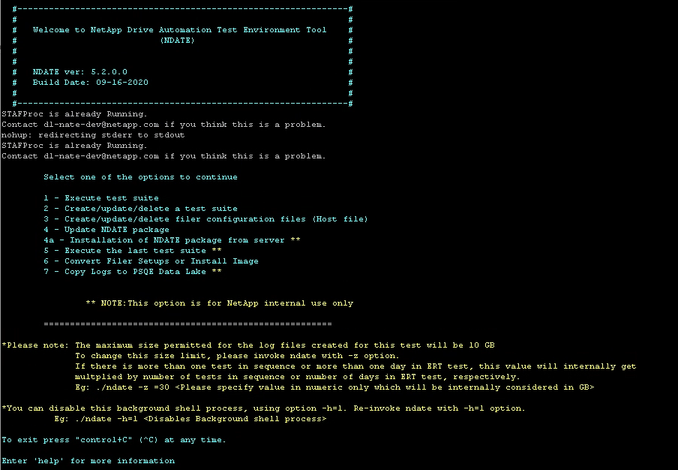
Figure 2
A menu of options and a note to change the log size is displayed. Follow the instructions given there if you need to change the log size.

Option 1 – Execute Test Suite
Option 1 from the NDATE menu is used to execute existing test suite. A list of available test suites will be displayed. Enter the name of the desired test suite and press Enter. If there are no previously created test suites, NDATE will force you to create a new test suite.
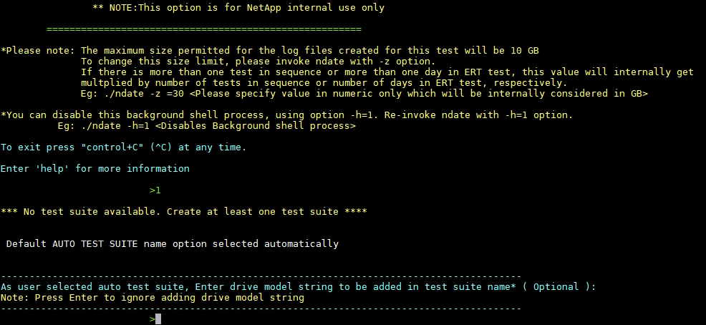
Figure 3

Refer 2.1.2.1-Test Suite Name, which is available in this document for guidelines on test suite creation.

Option 2 – Create/Update/Delete Test Suite
OPTION 2 in NDATE is used to create, update, and delete test suites. If you select this option, NDATE will prompt you to create/update/delete a test suite.
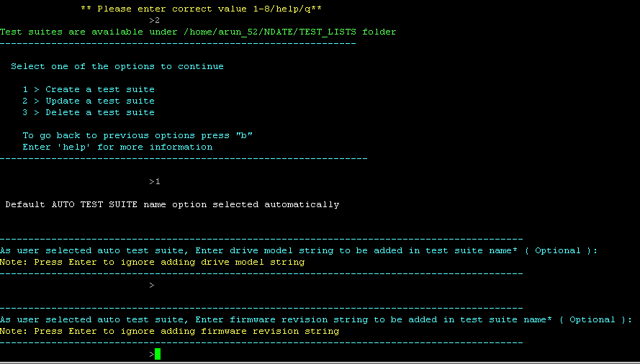
Figure 4
You can enter a drive model or firmware version to create a unique test suite name. These are optional fields. You can press Enter key to proceed.

Test Suite Name
Test cases are executed by the test suite. Test suite is a combination of test cases and it’s configuration details. NDATE allows you to define a name/ firmware number/ revision number/ drive id etc. of your choice which adds a meaningful name for the test suite. You can skip these optional fields by pressing Enter key.

Selecting Test Type/Config Type
NDATE v5.2.0 supports ZNS/SDF drives. Based upon your selection of configuration type, available groups and tests will be displayed.
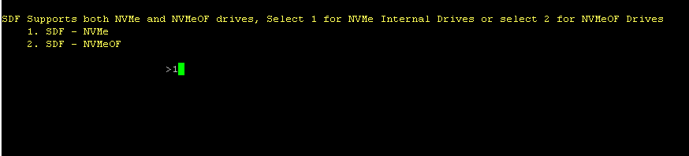
Figure 5
Based on the configuration option that you selected, test scripts will be displayed.
- For SDF- NVMe – Use Option-1 to select SDF/ZNS supported scripts
- For SDF- NVMeOF – Yet to design scripts under this section

Group Listing
Based on the selected test type, a list of available groups will be displayed. You will be prompted to select the required group based on the test case.
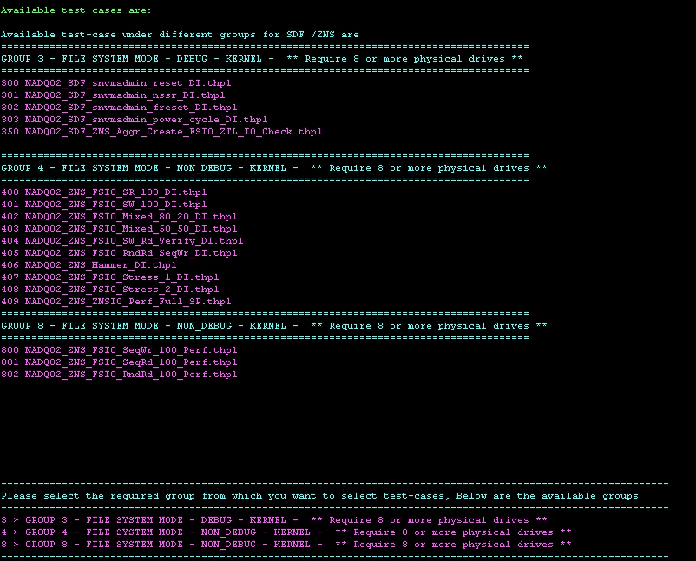
Figure 6

List of tests under selected group.
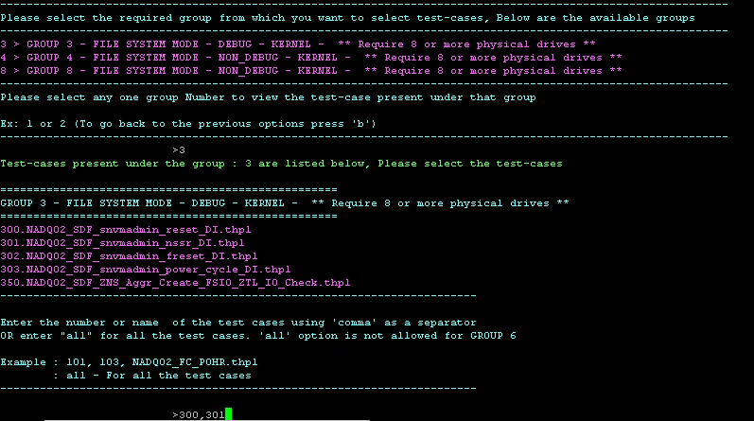
Figure 7

Filer Selection
You will have filer configs under “NDATE/FILER_INFO”. NDATE will display available filers for test execution. If no filer config file is present, use option 3(Ref 2.1.3 Option 3 – Create/Update/Delete Filer Configuration Files, in this document) from the main menu and create the new filer config with all relevant details, then select two (2) filers for execution of the prior selected test.
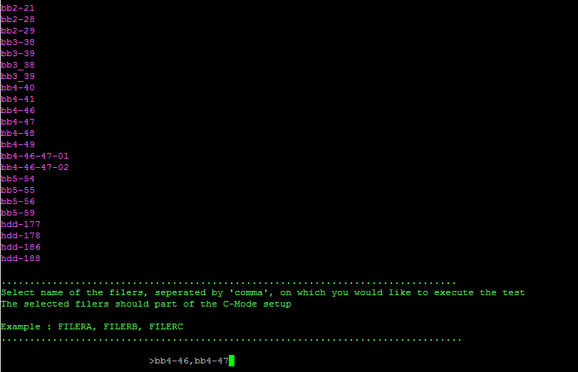
Figure 8

Test Execution
After selecting the required filers, NDATE will prompt to execute the test suite. Press "y" and the test suite execution will begin. The location and relevant details concerning the log directory will be printed on the console.
Figure 9
After the test suite is executed, you will receive an email with a status update including results/logs which are available under the prior specified log directory.

Option 3 – Create/Update/Delete Filer Configuration Files
Filer configuration files are used to store relevant characteristics of each filer used for configuration reference by NDATE. Each filer must have a filer configuration for NDATE to execute on that setup. All required details of each filer must be provided in the filer configuration files. Filer configuration file(s) must be created before using that filer in an NDATE environment, Filer creation/updating configuration file can be done using VI editor or using CLI. It performs basic parameter validation. Select option 3 from the main menu.
NDATE will prompt filer configuration menu.
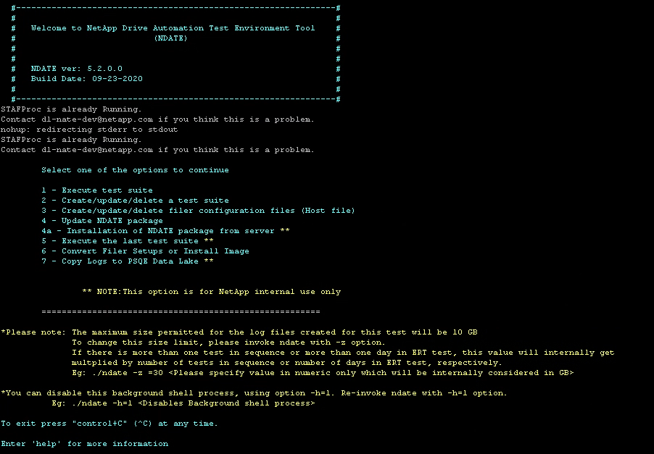
Figure 10
You can create and delete filer configs using the above options.
Enter the filer name you wish to create or modify if a filer config is available. NDATE will open the filer config for editing. If the filer config is not available, NDATE will create one and provide the relevant filer details.
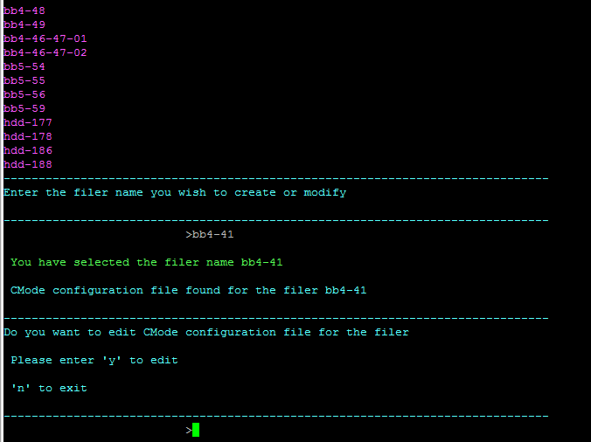
Figure 11
After you select the required option, filer details will be displayed for editing. Thereafter, you can edit/update/add filer details and save them by using :wq! command. This will save the filer config and prompt for confirmation.
All required parameters are necessary to proceed. Press CTRL + C if you want to exit or if you do not have all the details of the filer.
Enter "f" to finish editing.
Follow the same steps for partner node/filer.
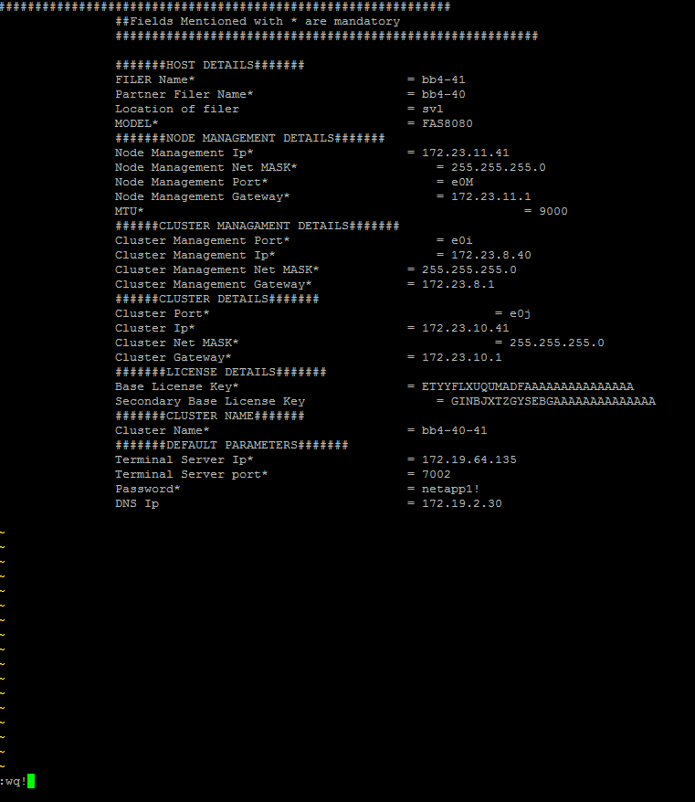
Figure 12

Sample filer info template looks like Figure 12
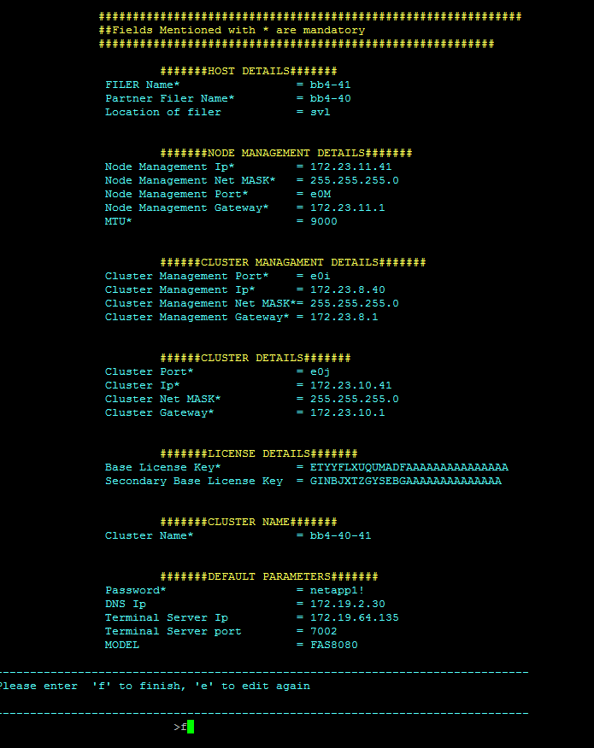
Figure 13

Once the filer details are filled and saved, NDATE will prompt the filer details and user can confirm it by typing ‘f’. To edit any field type ‘e’.

Option 4 – Update NDATE Package
This option will update all the test files that are available in the NDATE package. If user deletes any tests files and wants to get those files back, Invoke ./ndate command and select option 4 from the main menu.

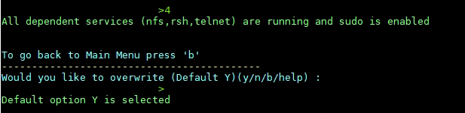
Figure 14
Press Enter key or Y for all prompts.

Option 5 – Execute the Last Test Suite
This option will run the last test suite that was executed. If you press Enter, the last executed test will be selected and marked as Default. You can choose any test by providing the name that was displayed. For all other prompts, press Enter key to start test instantly.
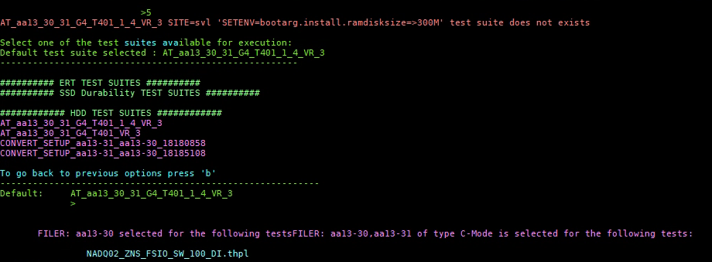
Figure 15
IMPORTANT
For Apollo, Auto switching of a kernel is NOT supported, The same kernel (debug or non-debug) MUST be loaded in both image locations.

Test Report Analysis
NDATE generates a test specific NDATE log, a Console log, an END log, a result log, also a summary log for analysis. For cluster setup, it generates separate logs for the two filers (two NDATE logs, two Console logs, two END logs and two result logs). While using cluster setup, some commands need to be executed in parallel on both the filers. This is accomplished by using a subtest. When these parallel processes execute, two separate log files are created, one for each filer. The name of these log files is similar to the runid associated with the subtest. These log files will contain the output of the command executed through the subtest. The main logs indicate the start and end of the subtest on both of the filers. After the test, check the test status from the ‘Summary result log’ and look for minimum log details from ‘Test result log’. Check the ‘nate log file’ or console log if more information is required. The parser will parse .log file and generate a readable text file.
The SYSTEM LOGS folder under main log directory will contain both ems logs and sktrace logs. The sktrace logs contain the NVMe commands which are further sent to the drives for the completion status. For NVMe testing, sktrace logs provides more drive specific details than ems logs for failure analysis. sktrace logs collected for all tests other than performance will not record any IO commands sent to the drives. For performance tests, NDATE will generate sktrace logs that records all IOs sent to the drive during the entire test duration. A separate parser is available to parse this sktrace log to identify the traffic pattern coming to the drive.
The location of the log and result files generated are mentioned by the wrapper on the Client Host console. The parser will determine the overall pass/fail state of a test case. The parser executes after each test case execution and decides the pass/fail based on the rules defined for the test case. The parser takes the log data and compares with the rule files (common rules and test case specific rules). Common rules are based on EMS errors. The parser generates one consolidated results file for all the test cases running on the different filers and also generates a readable result file for each log.
Copyright Information
Copyright © 2020 NetApp, Inc. All Rights Reserved. Printed in the U.S. No part of this document covered by copyright may be reproduced in any form or by any means—graphic, electronic, or mechanical, including photocopying, recording, taping, or storage in an electronic retrieval system—without prior written permission of the copyright owner.
Software derived from copyrighted NetApp material is subject to the following license and disclaimer:
THIS SOFTWARE IS PROVIDED BY NETAPP “AS IS” AND WITHOUT ANY EXPRESS OR IMPLIED WARRANTIES, INCLUDING, BUT NOT LIMITED TO, THE IMPLIED WARRANTIES OF MERCHANTABILITY AND FITNESS FOR A PARTICULAR PURPOSE, WHICH ARE HEREBY DISCLAIMED. IN NO EVENT SHALL NETAPP BE LIABLE FOR ANY DIRECT, INDIRECT, INCIDENTAL, SPECIAL, EXEMPLARY, OR CONSEQUENTIAL DAMAGES (INCLUDING, BUT NOT LIMITED TO, PROCUREMENT OF SUBSTITUTE GOODS OR SERVICES; LOSS OF USE, DATA, OR PROFITS; OR BUSINESS INTERRUPTION) HOWEVER CAUSED AND ON ANY THEORY OF LIABILITY, WHETHER IN CONTRACT, STRICT LIABILITY, OR TORT (INCLUDING NEGLIGENCE OR OTHERWISE) ARISING IN ANY WAY OUT OF THE USE OF THIS SOFTWARE, EVEN IF ADVISED OF THE POSSIBILITY OF SUCH DAMAGE.
NetApp reserves the right to change any products described herein at any time, and without notice. NetApp assumes no responsibility or liability arising from the use of products described herein, except as expressly agreed to in writing by NetApp. The use or purchase of this product does not convey a license under any patent rights, trademark rights, or any other intellectual property rights of NetApp.
The product described in this manual may be protected by one or more U.S. patents, foreign patents, or pending applications.
Data contained herein pertains to a commercial item (as defined in FAR 2.101) and is proprietary to NetApp, Inc. The U.S. Government has a non-exclusive, non-transferrable, non-sublicensable, worldwide, limited irrevocable license to use the Data only in connection with and in support of the U.S. Government contract under which the Data was delivered. Except as provided herein, the Data may not be used, disclosed, reproduced, modified, performed, or displayed without the prior written approval of NetApp, Inc. United States Government license rights for the Department of Defense are limited to those rights identified in DFARS clause 252.227-7015(b).
Trademark Information
NETAPP, the NETAPP logo, and the marks listed at http://www.netapp.com/TM are trademarks of NetApp, Inc. Other company and product names may be trademarks of their respective owners.

