NDATE v5.2.1 User Guide

Date: September 2020

Revision: A1

Contents
1.0 NDATE Requirements 4
1.1 Drive Test Configuration 4
1.2 Client Host Configuration 4
1.3 Web Server ONTAP Kernel Installation 4
1.4 Terminal Server 5
1.5 User Access Levels 5
1.6 Test Fabric Knowledge 6
2.0 Using NDATE 6
2.1 Wrapper 6
2.1.1 Option 1 – Execute Test Suite 8
2.1.2 Option 2 – Create/Update/Delete Test Suite 9
2.1.2.1 Test Suite Name 9
2.1.2.2 Selecting Test Type/Config Type 10
2.1.2.3 Group Listing 11
2.1.2.4 Filer Selection 13
2.1.2.5 Test Execution 14
2.1.3 Option 3 – Create/Update/Delete Filer Configuration Files 15
2.1.4 Option 4 – Update NDATE Package 19
2.1.5 Option 5 – Execute the Last Test Suite 19
2.1.6 Option 6 – Convert Filer Setup or Install Image 21
3.0 Test Report Analysis 22
4.0 Client IO Guide 24
4.1 Required Equipment 24
4.2 SW Requirements 24
4.2.1 NDATE 5.2.1 25
4.3 IP Requirements 25
4.4 Switch Details: Cisco Nexus 3132Q-V 26
4.5 Client IO Connection Diagram 26
4.5.1 Apollo Client Connection 26
4.6 SW INSTALLATION AND CONFIGURATION 27
4.6.1 Installation of SIO tool 27
4.6.3 Configure hostname on Client 29
4.6.4 Configuring Client Port and Route 29
4.7 EXECUTING CLIENT IO 31
4.7.1 Connection Diagram: 31
4.7.1.1 Apollo Connection Diagram 31
4.7.1.2 Apollo-Tahiti connection Diagram 32

NDATE Requirements
To successfully run NDATE, it is important to ensure that all requirements are met. This document explains about those requirements.

Drive Test Configuration
NDATE is a tool that is primarily used to execute automated NVMe drive tests during the pre-qualification phase at various drive vendor sites as well as during the qualification phase at NetApp. NDATE has been tested with the AFF series of filers. These filers should be loaded with the respective kernel version required for product qualification.

Client Host Configuration
NDATE is installed on the Client Host for executing the automated tests on the specified filer(s). Currently, NDATE tool must be installed and executed from Client Host running Linux OS. NDATE tool has been tested on Client Host(s) running i386-redhat-rhel4, i386-redhat-rhel5, 32-bit Linux OS Distributions Red Hat Linux (8 or higher), and Fedora Linux (2 and above) Red Hat Linux OS - Enterprise Server 5 (64-bit).

Web Server ONTAP Kernel Installation
NDATE 5.2.1 supports Voodoo Ranger (VR) kernel. For installation of the image, VR kernel image should be located on a functioning web server and the complete path of the kernel location should be added within NDATE when it prompts for the image location..
For example: https://172.23.8.10/<image_location>
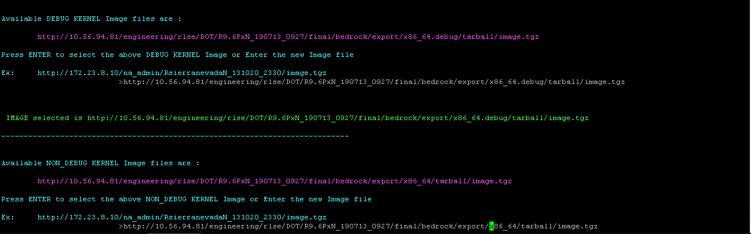
Figure 1

Terminal Server
A configured terminal server is required for NDATE to execute automated drive qualification tests because NDATE will connect to the specified filers using the terminal server IP Address as well as the serial port (#) at which the filer is connected to this terminal server.

User Access Levels
NDATE is available for use by NetApp Storage Media Engineering Team as well as by various Drive Vendors for prequalification testing of drives.
The installation of NDATE is done on a Client Host. The execution of automated drive tests on a given filer setup can be done by any non-privileged user. However, the user should have sudo privileges for executing the tests.

Test Fabric Knowledge
As a test user, you should have a basic understanding of the following:
- Filer Network Configuration Terminologies (e.g., IP Address, Gateway, Netmask)
- Filer Configuration setup (e.g., Terminal server, Port #)
- TFTP, Unix, and Web Server setup for ONTAP kernel file reference (netboot)
- Basic Linux/Unix commands

Using NDATE
After the installation is complete without any errors, you can invoke NDATE by executing it using the following command:
#./ndate
Invoking the help option when invoking NDATE will display options that can be used when running NDATE:
# ./ndate -h

Wrapper
After installing the package successfully, you can start running the main wrapper script (ndate). The options are explained in the following sub-sections.
NOTE:
Options marked ** is for internal NetApp use only. External users should not use these options. Using these internal options might lead to change in configurations which may lead to issue.
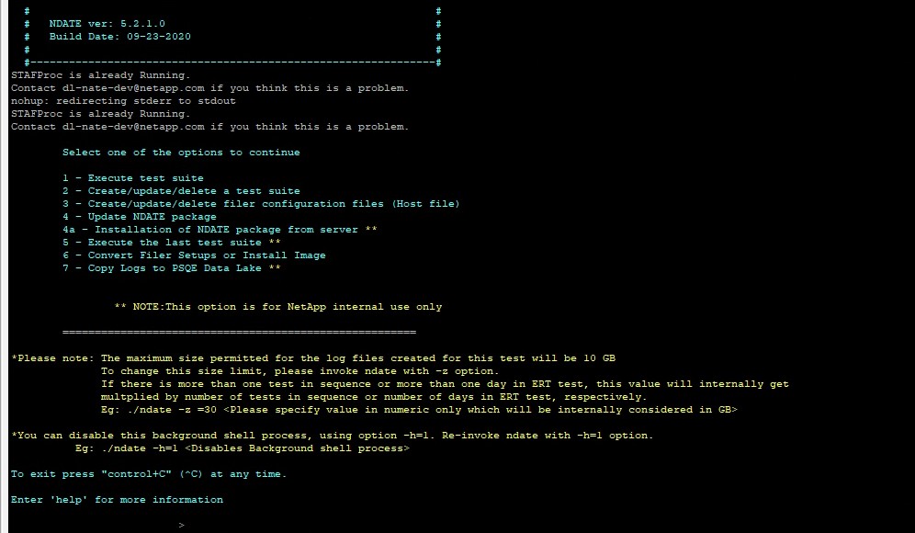
Figure 2
A menu of options and a note to change the log size is displayed. Follow the instructions given there if you need to change the log size.

Option 1 – Execute Test Suite
Option 1 from the NDATE menu is used to execute test suite that has previously been created. A list of available test suites will be displayed. Enter the name of the desired test suite and press Enter. If there are no previously created test suites, NDATE will force you to create a new test suite.
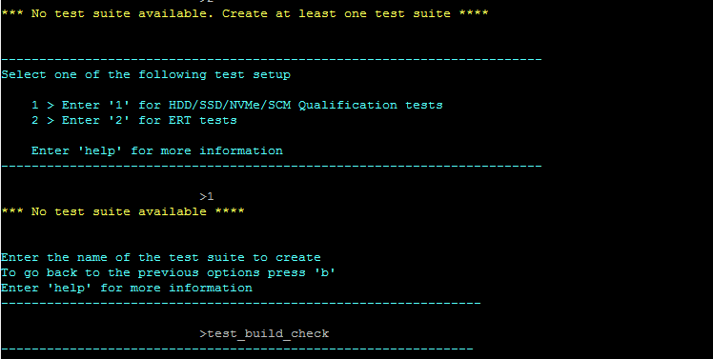
Figure 3

Option 2 – Create/Update/Delete Test Suite
OPTION 2 in NDATE is used to create, update, and delete test suites. If you select this option, NDATE will prompt you to create/update/delete a test suite.
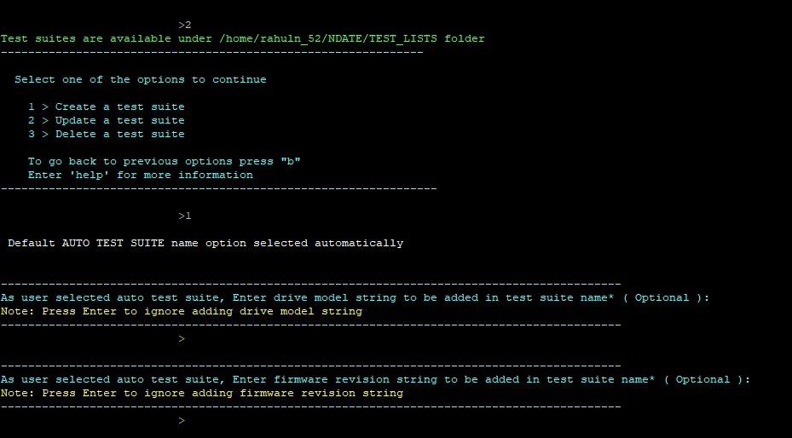
Figure 4
You can enter a drive model or firmware to create a unique test suite. These are optional fields. You can press Enter to proceed.

Test Suite Name
A test suite is a combination of test cases and filers on which test cases will be executed. NDATE will allow you to define a name/firmware number/revision number/drive id etc. of your choice which adds a meaningful name for the Test suite. These are optional fields, you can skip them by pressing Enter.

Selecting Test Type/Config Type
NDATE v5.2.1 supports NVMe, Tahiti and SDF configs. Available groups and tests will be displayed based upon the configuration types that you selected.
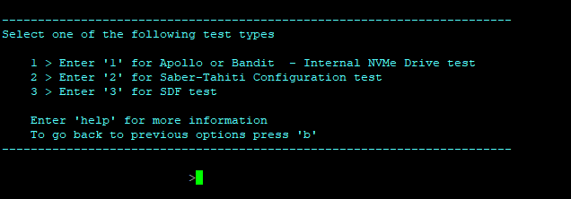
Figure 5
Based on the configuration option that you selected, test scripts will be displayed.
- For NVMe - Supports only internal drives. Use option 1 for Internal NVMe drives
- For Tahiti - Use option 2 to select Tahiti-supporting scripts
- For SDF - Use option 3 to select SDF-supported test

Group Listing
To select a test and execute, select required groups from the displayed available groups. After selecting a group, a list of available tests will be displayed.
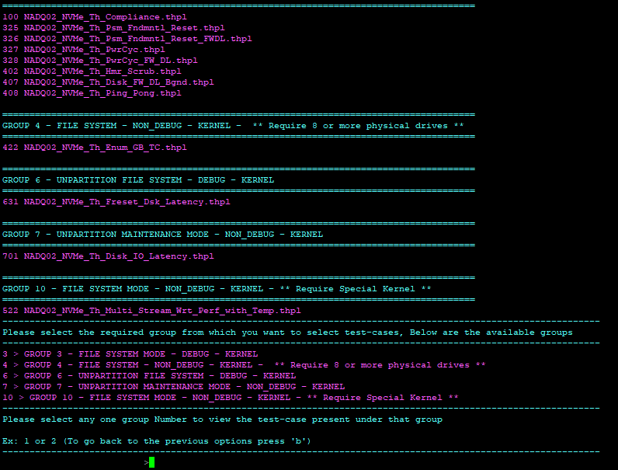
Figure 6

For example: List of tests that could be selected under group 3.
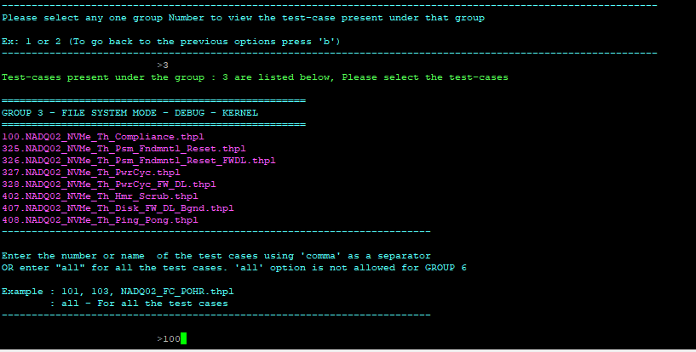
Figure 7

Filer Selection
You will have filer configs under “NDATE/FILER_INFO”. NDATE will display available filers for test execution. If no filer config file is present, use option 3 from the main menu and create the new filer config with all relevant details, then select two (2) filers for execution of the prior selected test.
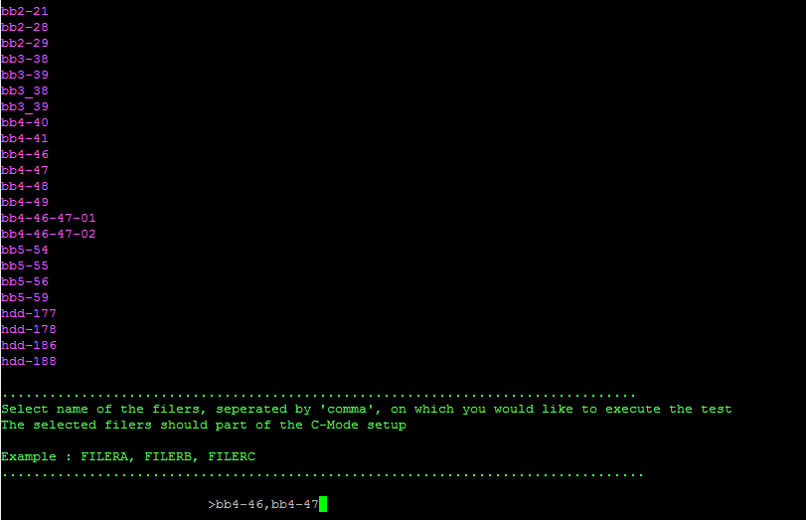
Figure 8

Test Execution
After selecting the required filers, NDATE will prompt to execute the test suite. Press "y" and the test suite execution will begin. The location and relevant details concerning the log directory will be printed on the console.
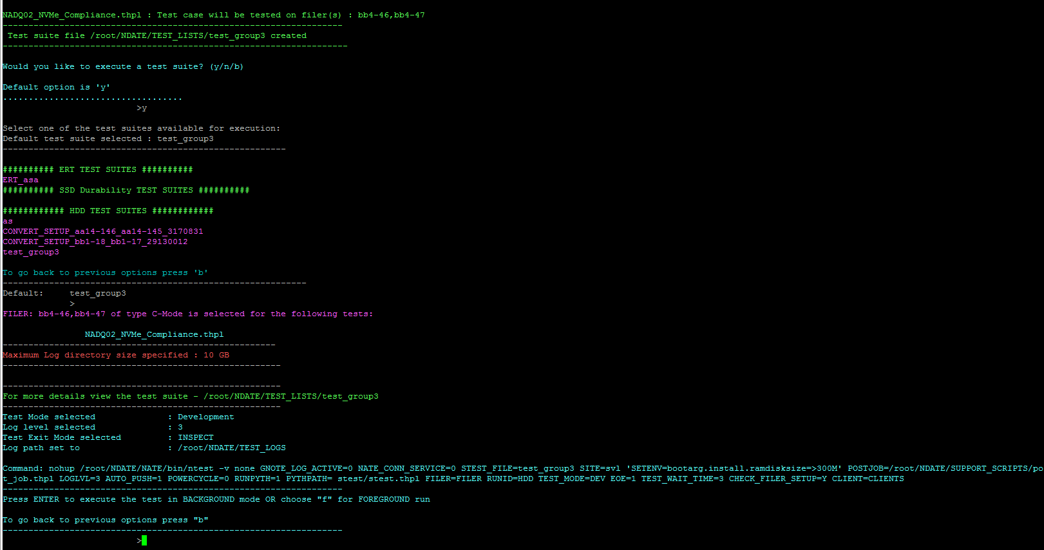
Figure 9
After the test suite is executed, you will receive an email with a status update including results/logs which are available under the prior specified log directory.

Option 3 – Create/Update/Delete Filer Configuration Files
Filer configuration files are used to store relevant characteristics of each filer used for configuration reference by NDATE. Each filer must have a filer configuration for NDATE to execute on that setup. All required details of each filer must be provided in the filer configuration files. Filer configuration files must be created before using that filer in an NDATE environment. Filer creation/updating configuration file can be done using VI editor or using CLI. It performs basic parameter validation. You select option 3 from the main menu.
NDATE will prompt filer configuration menu.
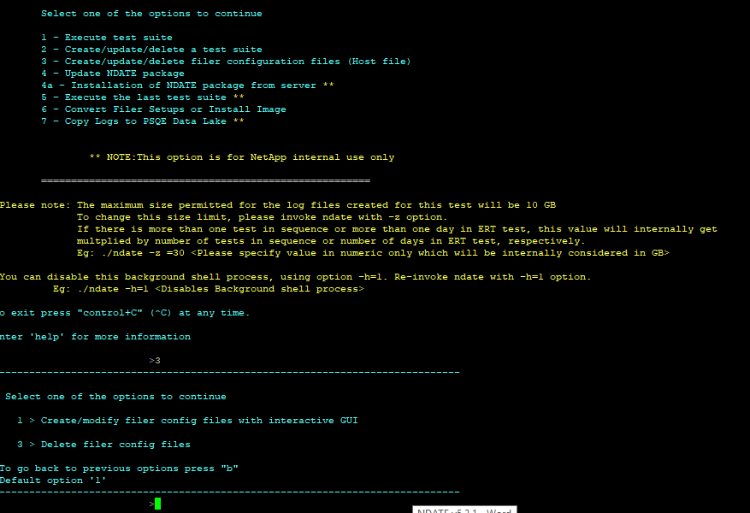
Figure 10
You can create and delete filer configs using the above options.
Enter the filer name you wish to create or modify if a filer config is available, NDATE will open the filer config for editing. If the filer config is not available, NDATE will create one and provide the relevant filer details.
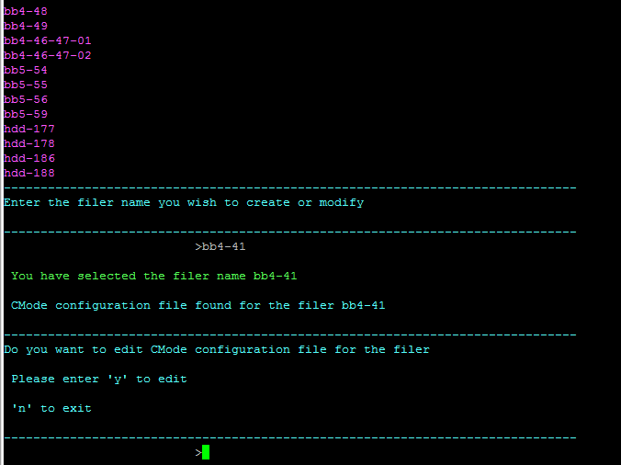
Figure 11
After you select the required option, filer details will be displayed for editing. Thereafter, you can edit/update/add filer details and save them by using :wq! command. This will save the filer config and then prompt for confirmation.
All required parameters are necessary to proceed. Press CTRL + C if you want to exit or if you do not have all the details of the filer.
Enter "f" to finish editing.
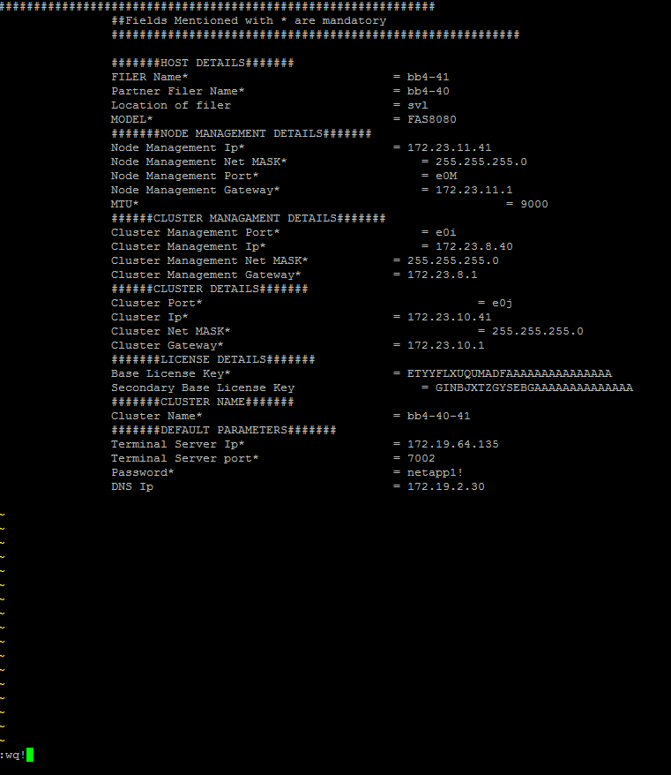
Figure 12

Follow the same steps for partner node/filer.
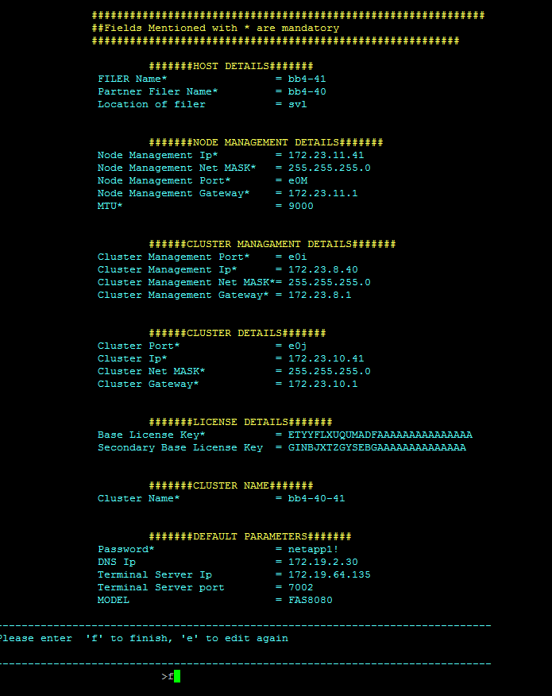
Figure 13

Option 4 – Update NDATE Package
NDATE has to be correctly installed before updating. Delete any previous tar.gz files using below command.
rm -rf *.tar.gz
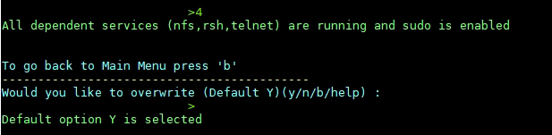
Figure14
Copy v5.2.1 NDATE package files - ndate, NDATE.tar.gz, and PNATE.tar.gz to home directory before using this option.

Option 5 – Execute the Last Test Suite
This option will run the last test suite that was executed. If you press Enter, the last executed test will be selected and marked as Default. You can choose any test by providing the name that was displayed. Press Enter to start tests instantly for all other inputs.
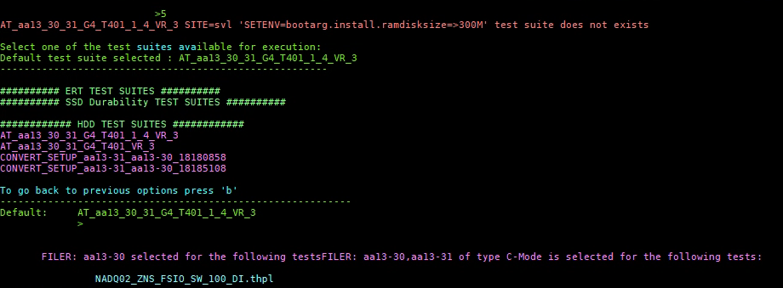
Figure 15

Option 6 – Convert Filer Setup or Install Image
NDATE has an option to wipe configuration and create a cluster. This method is preferred before executing a given test because NDATE will automate a given setup for use in testing.
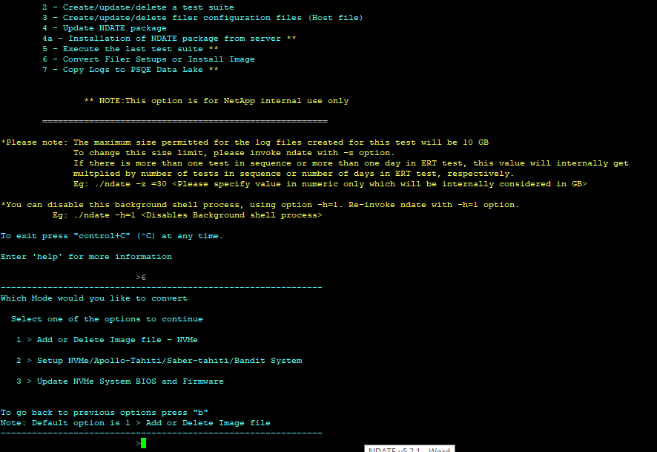
Figure 16
Selecting option 6 from main menu will list available options.
- To add or Delete Image use option 1
- To setup filers in maintenance mode or File System mode select option 2
- To update NVMe BIOS and Firmware use option 3

Test Report Analysis
NDATE generates a test specific NDATE log, a Console log, an END log, a result log, and also a summary log for analysis. For cluster setup, it generates separate logs for the two filers (two NDATE logs, two Console logs, two END logs, and two result logs). While using cluster setup, some commands need to be executed in parallel on both the filers. This is accomplished by using a subtest. When these parallel processes execute, two separate log files are created, one for each filer. The name of these log files is similar to the runid associated with the subtest. These log files will contain the output of the command executed through the subtest. The main logs indicate the start and end of the subtest on both of the filers. After the test, check the test status from the ‘Summary result log’ and look for minimum log details from ‘Test result log’. Check the ‘nate log file’ or console log if more information is required. The parser will parse .log file and generate a readable text file.
The SYSTEM LOGS folder under main log directory will contain both ems logs and sktrace logs. sktrace logs will contain the NVMe commands send to the drives and the completion status. For NVMe testing, sktrace logs provide more drive-specific details than ems logs for failure analysis. sktrace logs collected for all tests other than performance will not record any IO commands send to the drives. For performance tests, NDATE will generate sktrace logs that record all IOs send to the drive during the entire test duration. A separate parser is available to parse this sktrace log to identify the traffic pattern coming to the drive.
The location of the log and result files generated are mentioned by the wrapper on the Client Host console. The parser will determine the overall pass/fail state of a test case. The parser executes after each test case execution and decides the pass/fail based on the rules defined for the test case. The parser takes the log data and compares with the rule files (common rules and test case specific rules). Common rules are based on EMS errors. The parser generates one consolidated results file for all the test cases running on the different filers and also generates a readable result file for each log.

Copyright Information
Copyright © 2020 NetApp, Inc. All Rights Reserved. Printed in the U.S. No part of this document covered by copyright may be reproduced in any form or by any means—graphic, electronic, or mechanical, including photocopying, recording, taping, or storage in an electronic retrieval system—without prior written permission of the copyright owner.
Software derived from copyrighted NetApp material is subject to the following license and disclaimer:
THIS SOFTWARE IS PROVIDED BY NETAPP “AS IS” AND WITHOUT ANY EXPRESS OR IMPLIED WARRANTIES, INCLUDING, BUT NOT LIMITED TO, THE IMPLIED WARRANTIES OF MERCHANTABILITY AND FITNESS FOR A PARTICULAR PURPOSE, WHICH ARE HEREBY DISCLAIMED. IN NO EVENT SHALL NETAPP BE LIABLE FOR ANY DIRECT, INDIRECT, INCIDENTAL, SPECIAL, EXEMPLARY, OR CONSEQUENTIAL DAMAGES (INCLUDING, BUT NOT LIMITED TO, PROCUREMENT OF SUBSTITUTE GOODS OR SERVICES; LOSS OF USE, DATA, OR PROFITS; OR BUSINESS INTERRUPTION) HOWEVER CAUSED AND ON ANY THEORY OF LIABILITY, WHETHER IN CONTRACT, STRICT LIABILITY, OR TORT (INCLUDING NEGLIGENCE OR OTHERWISE) ARISING IN ANY WAY OUT OF THE USE OF THIS SOFTWARE, EVEN IF ADVISED OF THE POSSIBILITY OF SUCH DAMAGE.
NetApp reserves the right to change any products described herein at any time, and without notice. NetApp assumes no responsibility or liability arising from the use of products described herein, except as expressly agreed to in writing by NetApp. The use or purchase of this product does not convey a license under any patent rights, trademark rights, or any other intellectual property rights of NetApp.
The product described in this manual may be protected by one or more U.S. patents, foreign patents, or pending applications.
Data contained herein pertains to a commercial item (as defined in FAR 2.101) and is proprietary to NetApp, Inc. The U.S. Government has a non-exclusive, non-transferrable, non-sublicensable, worldwide, limited irrevocable license to use the Data only in connection with and in support of the U.S. Government contract under which the Data was delivered. Except as provided herein, the Data may not be used, disclosed, reproduced, modified, performed, or displayed without the prior written approval of NetApp, Inc. United States Government license rights for the Department of Defense are limited to those rights identified in DFARS clause 252.227-7015(b).
Trademark Information
NETAPP, the NETAPP logo, and the marks listed at http://www.netapp.com/TM are trademarks of NetApp, Inc. Other company and product names may be trademarks of their respective owners.

Client IO Guide
This specification is intended to define the equipment as well as the process necessary for setting up and executing the NDATE 900 series of Client based IO performance tests. These tests can be performed initially on SAS and will be supported on NVMe, SATA, and on SSD in addition to HDDs.

Required Equipment
These tests must be performed on an 8080 filer unless otherwise specified. In all cases, tests should be performed on the same type of system so that results can be compared against each other. The same number of drives should be used in all cases, even if the environment is fully drive bound. The filer should have 12G HBA’s and the enclosures used should be 12G enclosures unless otherwise specified. Any deviation from this will invalidate the results and will require the tests to be re-run after fixing physical shortcomings.

- 8080/Aurora/AFF800 Filer (or faster if specified by NetApp)
- 4x 10Gb to 40Gb break out cables to connect 8080 to 40Gb switch
- 12Gb enclosure with at least 8 drives
- 40Gb switch
- At least 1 dedicated client for IO with RHEL 6 +
- 40Gb NIC HBA for client to connect to Filer
- 1Gb NIC port for client to connect to network backbone

SW Requirements
There are some basic SW requirements including suitable NetApp Kernel versions and Linux versions that must be observed for everything to work properly. If these versions are not followed, then proper performance and or functionality of the tests may not be desirable.

- ONTAP Kernel LB1 RC2 or greater
- Client Linux machine must use Linux Kernel 2.6.32 (We have used RHEL 6.5 and know it works, your mileage may vary if you deviate from this)
  - The 40Gb IP address must be in the same subnet as the Filer’s 10/40Gb ports
  - The client system must have the host name configured. 20 IP addresses will be used for LIFs (not including HW).
- Future releases of NDATE will use 40 LIFs(IP addresses)
- The client 1Gb IP address must be in the same subnet as e0M

Note: For more information refer NDATE Client IO User Guide

NDATE 5.2.1
sio tool (Part of the package)
sio (Simple I/O Load Generator) is a tool to generate artificial I/O workloads against any device which:

- Supports numerous configuration variables (reads vs writes, etc.).
- Supports multiple devices and multiple threads.
- Collects a wide variety of statistics on I/O client machines and/or I/O servers.

Reference Link: http://danisaacs.com/temp/dansstuff/sio/sio.html#Overview

iozone (Part of the package)
Iozone is a file system benchmark tool. The benchmark generates and measures a variety of file operations. Iozone has been ported to many machines and runs under many operating systems.

Iozone is useful for determining a broad filesystem analysis of a vendor's computer platform. The benchmark tests file I/O performance for the following operations.

Read, write, re-read, re-write, read backwards, read strided, fread, fwrite, random read/write, pread/pwrite variants

The minimum RHEL/CentOS version for NDATE/IOzone is 6.10

Reference Link: https://linux.die.net/man/1/iozone

IP Requirements
- Client – static IP – 1Gb backbone – 1x
- Client – static IP – 40Gb backbone – 2x
- NDATE server – static IP – 1Gb backbone 1x (probably already exists)
- Filer IP – Node A (e0M) – 1Gb backbone – 1x
- Filer IP – Node B (e0M) – 1Gb backbone – 1x
- Filer IP – Node A Data – 10Gb or 40Gb 4x or 1x depending on speed. On 40Gb backbone.
- Filer IP – Node B Data – 10Gb or 40Gb 4x or 1x depending on speed. On 40Gb backbone.
- 40 IPs dedicated for LIFs per configuration. To be placed in LIF IP format file,
- NDATE_LIF_CONFIG.config available under FILER_INFO directory.

Switch Details: Cisco Nexus 3132Q-V

Figure 17

Client IO Connection Diagram

Apollo Client Connection

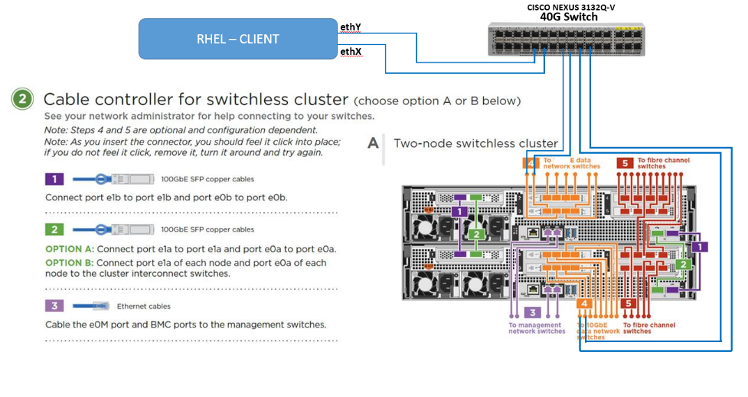
Figure 18

SW INSTALLATION AND CONFIGURATION

Installation of SIO tool
NOTE: All commands should be executed from client
- Copy SIO tool from NDATE package to /root on client sio_linux_639
- Link sio tool to /usr/bin/sio

  - cd /usr/bin
  - ln -s /root/sio_tool/sio_linux_639 sio

- Verify sio tool is properly configured using the below steps

- whereis sio
output: sio: /usr/bin/sio
- sio
output: Version 6.39

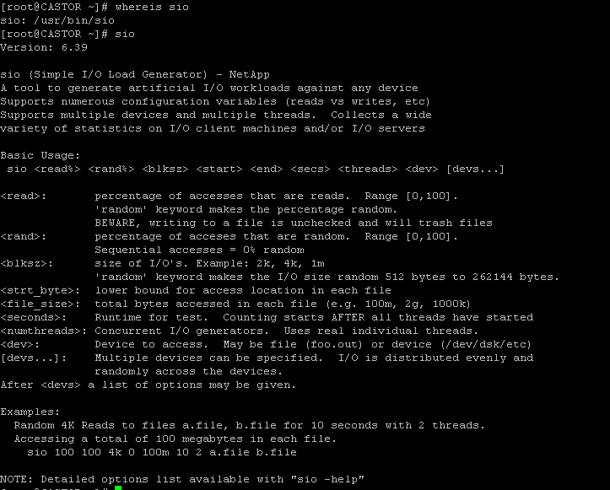
Figure 19

    - Installation of iozone tool - v5.2.1
NOTE: All commands should be executed from client

- Copy iozone tool from NDATE package to /root on client iozone
- Verify iozone tool is properly configured using the below steps

./iozone
output - Usage: For usage information type iozone -h

Configure hostname on Client
If you have not already configured your hostname, your hostname is likely “localhost”. From the client, execute the hostname command. The output should look like this kessler.lab.netapp.com if it is configured properly or should be localhost if not. If your hostname is localhost, edit the “network” file and fill with this content but use your values.

NETWORKING=yes
HOSTNAME=walker.lab.netapp.com
GATEWAY=172.23.9.1
NISDOMAIN=lab.netapp.com
Restart the network services using the following:
/etc/init.d/network restart

Configuring Client Port and Route
Configure all ports and routing parameters and verify client ports. The client will be accessed from NDATE via the 1 Gb ethernet and in our examples this will be ETH1. ETH2 and ETH3 are the data networks connected to the filers, and in our case, they are 10Gb but that may not be the case in all setups. Hopefully a properly configured performance setup will be using 40Gb HBA’s in the clients.
ETH1 must be on the same subnet as the NDATE server and the e0M of the Filers. ETH2 and ETH3 must be on the same subnet as the data network of the filers and in our case that is e0c and e0d. Once Aurora systems are in place this may change.

The following is an example and your environment may differ. Use appropriate IP addresses.
- From the client, configure the IPs for ETH2 and ETH3 enter the following commands:
ifconfig ETH 172.23.9.25 netmask 255.255.255.0
ifconfig ETH 172.23.9.26 netmask 255.255.255.0
- Verify your IP configuration using ifconfig –a
- Verify that the configured network interface default route has the same IP for both ETH2 and ETH3. To do this use the ip route show command. The output should look like this:

Sample output:
172.23.9.0/24 dev eth2 proto kernel scope link src 172.23.9.25
172.23.9.0/24 dev eth3 proto kernel scope link src 172.23.9.26
172.23.9.0/24 dev eth1 proto kernel scope link src 172.23.9.10 metric 1
169.254.0.0/16 dev eth2 scope link metric 1002
169.254.0.0/16 dev eth3 scope link metric 1003
default via 172.23.9.1 dev eth1 proto static

If the ETH2 and/or ETH3 route are not found, add the entries to the routing table with these steps.
cd /etc/sysconfig/network-scripts
delete all contents of this file

ls
vi route-eth2
The values to add to this file are an IP address followed by a mask. If you want to make use of LIF IP addresses, use 172.23.9.50 through 172.23.9.70. Below is an example of the content to add to the file.
- 172.23.9.0/24 via 172.23.9.25 dev ETH2
- Validate that the client is accessible from the NDATE server. Ping 172.23.9.10
- If the client and NDATE cannot be pings check the personality of the adapter and configure using this link:
https://www.youtube.com/watch?v=pJ3AYS98ODg&feature=youtu.be

EXECUTING CLIENT IO
Once you select a Client IO test, there is a series of information that you will need to input. This is a much more complicated test than the majority of other NDATE tests as it requires below information.

- The number of drives in the aggregate. (stick to the default unless otherwise instructed)
- The drive model to be tested as listed in sysconfig -v
- Client configured with a host name, and the host name of the client identified to NDATE.
- IP addresses for the data ports of the filers (for 8080 e0c and e0d)
- The IP addresses/range for the LIFs to be created. NDATE_LIF_CONFIG.config with all IP should be present, template is located under NDATE/FILER_INFO/
- The subnet for the entire data network including the LIFs.
- The tool to be used to generate IO (currently only SIO is supported)

Connection Diagram:

Apollo Connection Diagram
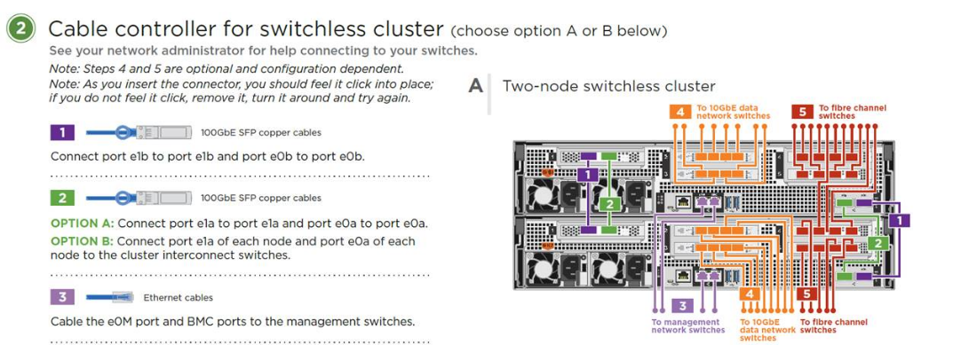

Figure 20

Apollo-Tahiti connection Diagram
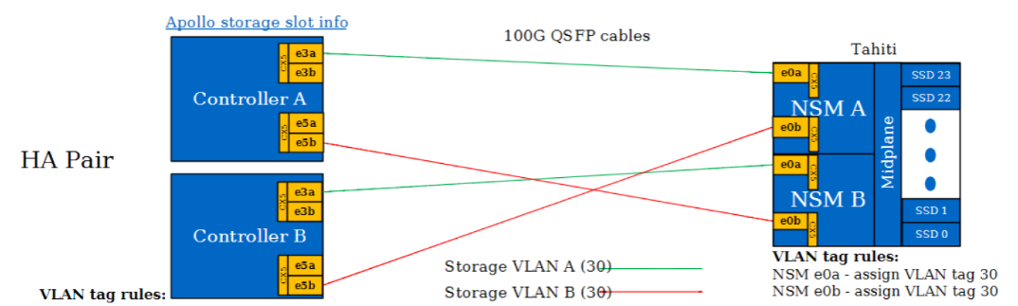
Figure 21

